DACS – Online Project   
Functional Specification for Website Functions

Author Liza Mair  
Date 8th March 2012   
Version 1.0 – Draft

Introduction

This document is the Functional Specification detailing the requirements and proposed solution for all functional areas identified for the new Website that is not specifically related to content of the website.

Project Scope

The scope of this specification document relates only to those areas of the website that require additional specification ie not related to the content of the website, but any functionality required to interface between the website and any other medium including on-line forms/ spreadsheets/ DBs or Triple R CRM System.

Distribution

This is a confidential document that should not be disclosed in whole or part to anybody other than directors and employees of DACS who have a need to know, and that it will be used only for the purpose for which it has been written.

Website Functional Areas

Overview of the proposed approach

This Introduction section covers, at a high level, the thoughts/assumptions on the three main areas for development :

* Secure Members Area
* On line Forms Submission
* Artist Search and Data Migration

Within each of these sections the proposed recommendation will be stated with additional options listed to provide the overall picture. The section that follows the introduction, will identify at a more detailed level those areas that require further specification for development.

Assumptions/Thoughts

Secure Members Area (first service provided is Payback)

DACS would like a single login from the website to enable online users to :

* Subscribe to emails/newsletters
* Set Communication preferences
* Submit payback request forms
* Manage their user account information – only currently applicable to Artist/Beneficiary/Artist Representative, but could be extended to Customers and AMPs.

Ideally, website users should only have a single logon to the DACS online membership area that then gives them access to their (MyDACS) account and any services they are signed up to, ie Payback service. The scope of the secure membership area initially covers the online registration and log-in functions required for Payback, however this could be amended/extended to include access to other business stream services within DACS, so that there is only one login/registration into the secure area for all members. Access could then be given to other services as they are provided in future phase developments. Initially the only business stream service is Payback but could be extended to ARR and CL as well as Customers and AMPs.

There is nothing, currently, within the secure membership area that would prevent anyone from registering as an online member. Ie you do not have to have submitted a payback claim to register as an online member.

DACS manage the claim process on behalf of their members, as works licensed via copyright Licensing are also eligible for Payback royalties. However, Artists that submit payback claims on line are not generally registered members of DACS.

Users submitting forms, whether Copyright Licensing requests, ARR sales information or Artist’s requests for either CL or ARR representation, should be able to do so without the need to register/login online. However, in the future, DACS may want to give users an option to sign in to the secure members area against any of these forms, so that the user can track their activity history. This is a future phase option.

In addition, there is a requirement to enable users to sign up for email/newsletters. However, a webuser shouldn’t have to be an online member to subscribe to emails/newsletters.   
Against all of the online forms, DACS should provide the ability to indicate sign up for email/newsletter at the point of submission of these types of forms as they will be entering a name and email address as part of the submission.

**Online member of DACS – current position**

Currently only web users that want to submit a payback claim online will be required to login into the secure members account area. This primarily relates to webusers who are Artists/Beneficiaries and Artist Representatives and who have submitted payback claims in the last three years. There are other types of web user, such as Artists/Beneficiaries who will be submitting online requests, or Customers requesting Licenses or AMPs submitting sales information for ARR who in Phase 1 will not be required to register for an account to carry out these activities.

The initial development phase of the website should enable the storage of submitted request details on custom tables within the CMS. This would then allow reporting of user interactions and also enable us to provide a user activity history in future phases of development.

**Future phases**

In future phases the secure membership area could be extended to allow additional types of user to register and provide them with additional business stream services.

Additional business stream services could be offered via the secure member’s area such as automated submission of Copyright Licensing requests by Customers or an Artist’s view of distributions paid for Copyright Licensing or ARR etc. Users would then login to the secure area and then sign up to the various services on offer to them. If this is the direction that DACS is going in, then you may want to think about ensuring that information submitted via the website now, on online forms is held in the CMS so that it can be made available later.

Although current online submission of forms would not require login by users, in the future, we could promote logging in to the secure area to then be able to provide to webusers an activity history of their actions on the website as well as account information and even payment information, if relevant. This would mean that if a user wants to be able to see a history of activities that they have carried out on the website, such as requests for licenses or submission of ARR sales information then they would need to log in before being able to submit these online forms.

For those users who are submitting requests for DACS representation, then on confirmation of representation by DACS, for CL or ARR, then these users could be prompted/directed to register/logon. For those users that are members of DACS ie for CL or ARR, if they register for DACS online, then the secure area would show their status in their personal details.

Would potentially still want users to be able to submit on line forms without the need to login, but if they do login in then whatever they submit can be tied back to the their webuser details.

NOTE: allowing signup/signin for anything other than Payback Claims is an incredibly low priority for this phase of the site. We should only do this if it is trivially easy to achieve.

We should outline what the process might be for exposing order data / payment data in the future, and what the process for marrying triple R records for people with web registrations might be after the initial Payback migration.

This requires us understanding what the registration / membership / manual dedupe process is for payback accounts.

Thoughts:

* There is a benefit to storing form data / submissions against a user now, so that in future this can be exposed through [mydacs]
* If we do not do this now, we are creating a data migration process later if we want to expose historical orders
* Forcing people to sign up before submitting forms is bad practice
* We can offer the ability to register / sign up / sign in at the end of a form submission process
* This implies
  + It may be possible for someone to re-register if theyre already in triple R, so we need an internal process for checking if that person already exists in triple R as a web user when a form is submitted
  + We may need to plan for setting up customers as web users in the future
  + FUTURE There may be implications for setting up user accounts for the image hire system – does this interlink with TripleR? How are users managed there?

Potential User Flow for form submission / Sign in

1. User completes form and hits submit
   1. Form includes email address for user
2. Form is submitted to system
   1. System stores form contents in DB?
   2. System emails summary contents of form to user in confirmation email (NB, security? Need to identify any sensitive information here)
   3. System emails / sends form data to internal end point (ie, the person who needs to act on the contents of the form / process in Triple R)
   4. System displays confirmation page – your form is successfully sent.
3. Confirmation Page contains a ‘do you have a web account with DACS?’ prompt
   1. This prompt contains a sign-in box
   2. The page explains the benefits of signing in (In the future, you will be able to access all of your requests in our sign in area)
   3. The user can choose to sign in or sign up for an account
4. User signs in to existing account
   1. System stores the data against that user account?
5. User signs up for account
   1. Form asks for email address, password, user name
   2. User fills out, and submits
   3. System creates web user account?
   4. What if the email is identified as already in use?
      1. Display error, give user option of resetting password?
      2. REQUIRES PASSWORD RESET PROCESS HERE.
   5. Data stored against new account
   6. Internal workflow: check new web user account and merge if account already exists
      1. REQUIRE PROCESS FOR TRIPLE R MERGE HERE? MANUAL?

There are a number of different types of user on the DACS Website:

* Artists (Members – CL/ ARR) or Non Members of DACS, - payback claimants
* Beneficiaries (of an artist if deceased – payback claimants)
* Artist Representatives (Authorised Representatives) Payback claimants
* AMPs
* Sister Societies
* Customers - wishing to licence artworkJob Applicants
* Newsletter subscribers

Look at expanding User Case scenarios – identify all types of user and what they would require from the membership area – who exactly needs to be a member and what services do they get. Identify this for Phase 1 and also things to have in subsequent phases. Eg Payback users will be managed in Phase 1 but not CL/ARR members, although in the future DACS would expand the services for these two areas to allow online users to view their CL and ARR information that is currently held on Triple R.

**Full Registration** – For phase 1 of development, is only really required by those web users that wish to submit payback claims online. However, other users, ie those who are ARR or CL members of DACS (ie Artists/Beneficiaries or Artist Representatives) and even customers that request copyright licensing and AMPs that submit ARR details, may also want to register on-line so that they can manage their user details (MyDACS). Currently, there is nothing to stop anyone from registering on the site and then completing personal/bank details. If they then choose not to submit a claim form, makes no difference to DACS and the membership process.

The level/depth of information requested in registration process will depend on what type of user they are.

Signup to Email/Newsletters

Signup to email/newsletters ideally only requires an email address. Users of a website are unlikely to want to have to go through a login/register process to simply sign up for a newsletter. This email registration function could remain on Mailchimp.

Newsletters

The current mailing list is managed through Mailchimp. We need to

* Provide a mechanism for people to sign up for mailing list with just an email address (“Lazy registration”)
* Ensure that registered users of the site are
  + Presented with opt in forms for newsletters
  + Have easy access to opt out of newsletters
* Ensure that, if communication preferences are stored in two places (eg, Mailchimp and Triple R) that updating a preference in one location is reflected in the other
  + So we need to relate an email address on the mailing list in Mailchimp to an identity within the User Management system within the CMS / Triple R in order to manage opt in / opt out status centrally

Any webuser /member within the CMS / Triple R should have communication preferences associated with their account.

The mailing list send process must honour any communication preferences set by that user. This is a legal requirement.

Management of optin/out could be managed manually if the information is exposed in an easy to read way by triple R. Mailing preference could be stored externally to triple R if there is a sensible way of exposing the optin/out process to a signed in user – eg, by using embedded MailChimp form or the Mailchimp API.

Mandatory details for any member of site: Name, Email Address, Opt In

Optional: Type of user (artist, AMP, Ben/Heir, artist Rep, 'Other')

Payback User

May be

Known to DACS: pre exists in system, has been sent Username/Login details. Exists in Triple R

New Registrant: does not exist. Sets own username / login details. Requires creating in triple R.

DACS may want to enable any user to register as online members, which will effectively give them secure access to myDACS area. This will create a web user record with additional options to then subscribe to services offered, ie Payback initially.

Core Services offered by DACS via the website potentially

* Payback – claim form submission by Artist, Artist’s Representative or Beneficiary LOGIN REQUIRED
* ARR – resale of artworks. AMP submit sales data LOGIN NOT REQUIRED
* Copyright licensing – manage copyright on behalf of Artists by acting as an agent and selling licences to range of customers - LOGIN NOT REQUIRED
* Licensing an image – obtain a license to use an image in a project / product – LOGIN NOT REQUIRED

On line Submission Forms:

Currently, submitting a form or completing a request for something doesn’t necessarily mean that the user wants/needs to join DACS online. For the initial build we only need to offer a signin tot he secure members area for those submitting payback claims.

In the future, other users of online forms could be prompted to sign in so that whatever activities they carry out on the site can be tied to their webuser details and hence a record of the activity history can be kept. Assume that a migration of historical transaction data would be part of a later project.

|  |  |  |  |
| --- | --- | --- | --- |
| User | In Triple R | On line Form | Wireframe Ref |
| Customer | Account (Customer) | Licensing Copyright Works – apply on line |  |
| Art Market Professional (AMP) | Account (AMP) | Submit ARR online – send in ARR details from sales |  |
| Artist | Artist | Apply for ARR Representation |  |
|  |  | Apply for CL Representation |  |
|  |  | Apply for Payback |  |
| Authorised Representative | Authorised Representative | Apply for ARR Representation |  |
|  |  | Apply for CL Representation |  |
|  |  | Apply for Payback |  |
| Beneficiary | Beneficiary | Apply for ARR Representation |  |
|  |  | Apply for CL Representation |  |
|  |  | Apply for Payback |  |

Also: Web Users: Apply for job, sign up for newsletter.

**Where should these submitted forms go?**

When a form is submitted online, there are a number of possible options in terms of how that submitted form is handled.

**Recommended Solution**

The details submitted on the online forms will be sent via email to nominated DACS personnel for manual progression. A copy of the submitted details will also be sent back to the submitter as confirmation. This is the least secure option and is not appropriate for transmission of personnel information, such as bank details. In addition, there is no record of the information that can then be reported on/searched on as it is contained in an email format.

**Other options**

1. The details submitted on the online forms could be recorded in a custom table created in the CMS. The submission of the form would simply add a record into the custom table and a workflow would then send notification emails to nominated DACS personnel for manual progression, with a link in the email back to the table for review of the information. A copy email would also be sent to the submitter as confirmation. This also maintains a history of interactions.

The details submitted on the online forms could go directly into Triple R Queue/Cases as pending cases for review and authorisation. Include a workflow that then puts them into appropriate places within triple r depending on what they are. Ultimate solution would be to create a web service to put into Triple R in pending state, and then action to move the record on in the process ie creation of records in triple r, ie a copyright licence for a new/existing customer, ARR submission by an amp,etc. However, this level of development may well be something for a future release, but is not within scope for this first new release.NOTES: Indeed: the full 3. triple R integration is not in scope. Posting to a Database sounds like a more sensible solution: just displaying a page that confirms the form data on submit, and an internal interface that shows the data internally in an easy to copy / paste / port format.

There was some mention of the fact that ERR0003 – the copyright licensing work to generate an automatic identifier – was already done. Need to work out if this is the case, and if we need to plan around that if so: Paul implied it was more or less a done deal?

Secure Membership Area

Currently the only service provided in the secure membership area is for submission of payback claims. NB: The secure membership area will need to be updated to remove reference to payback and make it more generic so that it is a more general secure membership area for all webusers not specifically payback webusers(although payback will be the only service offered initially).

1.1.1 Payback for Artists

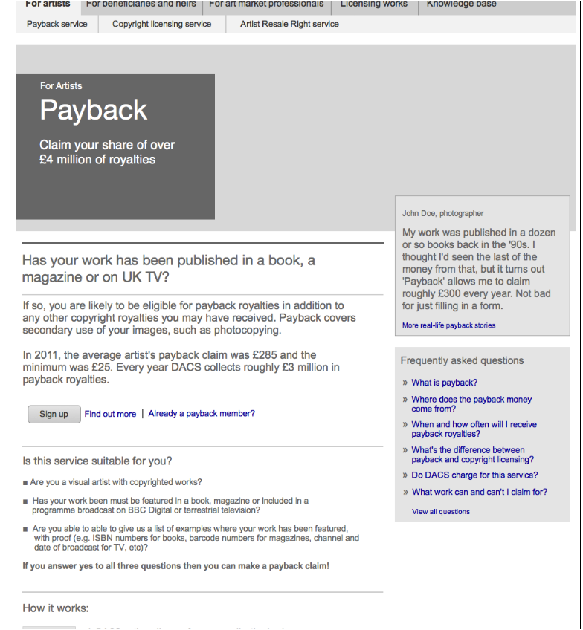

Register for Online Membership

A secure member’s area has been developed for payback claimants (DACS Collective). However, payback is just one of many services that DACS could offer online and hence the secure member’s area that has been developed as part of DACS Collective, could actually be used for all web users of DACS irrespective of whether they have currently signed up for the payback service or not. The account information area of the secure area is relevant to any webuser. Going forward, DACS will start to provide additional online services to which other webusers could sign up to through creating an account on DACS Online.

If the user selects Sign Up from the Payback Artist’s page then they will be taken to the login screen where they can select Register.

NB: We need to ensure that there is consistency between this user interface and the website so that it looks seamless to the web user.

NB this needs to reflect the livery of the main site, and use the same header / footer elements

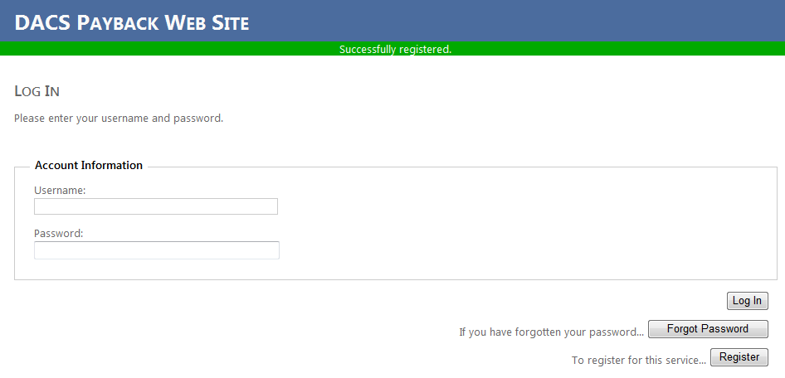

If the web user has not previously registered for DACS online, they would just select Register. They would then be presented with the Create A New Account page:

The user would then enter Account Credentials:

* Username: – user choice
* Password: – user choice
* Confirm Password:

And then Account Information

I am registering as – Artist/Beneficiary/Authorised Representative or Sister Society

Depending on user type selected, different information may be requested.

**For an Artist:**

* First Name:
* Last Name:
* DOB: - three separate fields DD/Month/YYYY
* E – mail:
* Confirm E-mail:

For a Beneficiary:

* First Name
* Last Name
* DOB
* Email
* Confirm Email

Need to confirm any additional fields for beneficiaries.

Same for Artist Representative/Sister Society and any other user we will support in secure membership area.

This screen is from the wireframes document, to bring it in line with the payback registration form we would need to add in a username field. See below:

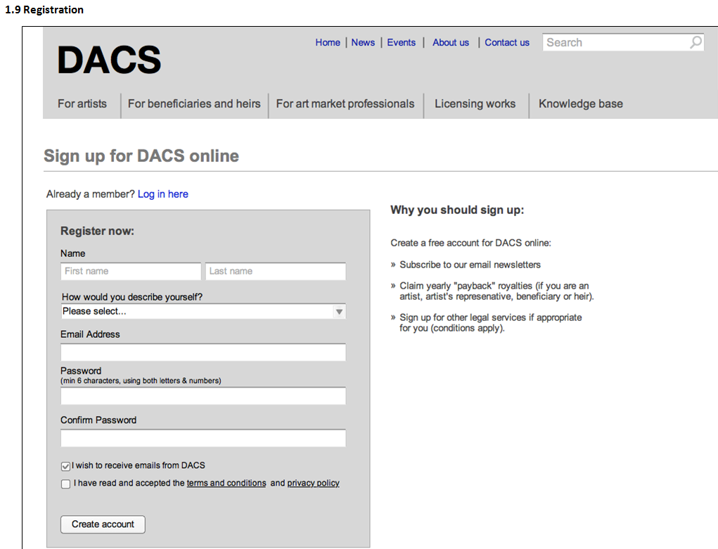

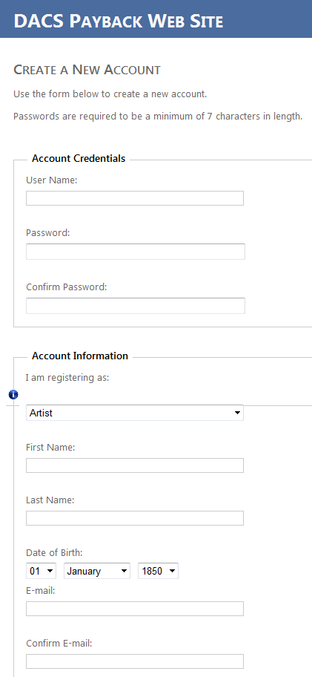

On registration, the following actions are done: irrespective of whether the user already exists in Triple R.

* Create record in webuser table

Depending on user type: (Additional types of users could be added to)

* Create Artist
* Create Beneficiary
* Send Verification email to user. Link in email allows them to continue with registration into the secure members area.
* Create and assign CRM Task = Review new Web user.

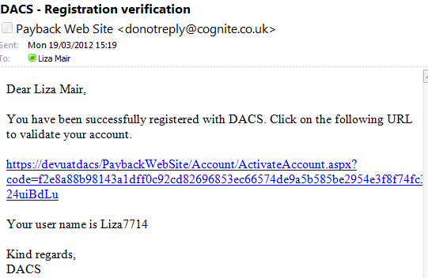

Question: where is this text held? Is it editable? Can additional messages be added?

NB – is there any way of shortening these URLS? What happens if they hard wrap?

**1.9.1 Now Check Your Email**

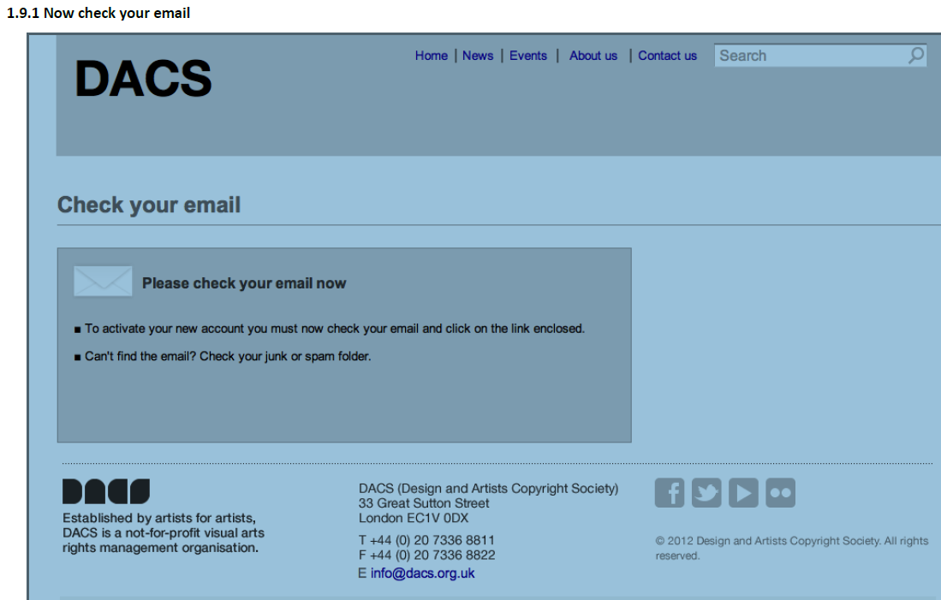

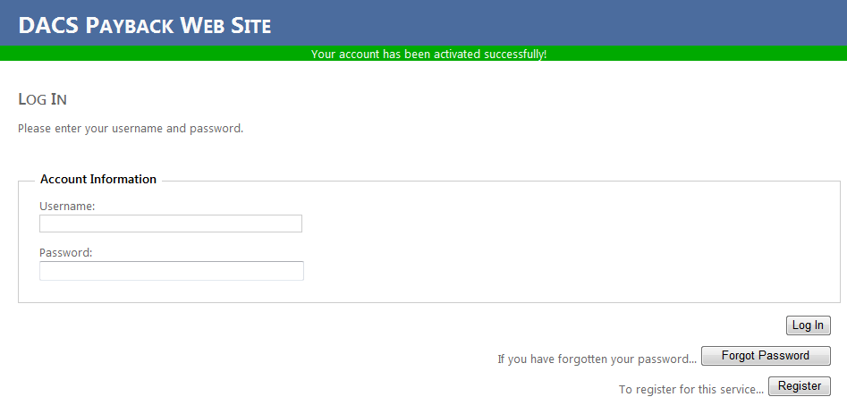

As part of the review task, a manual check will be made to see whether the identified Artist already exists in Triple R. If the Artist already exists in Triple R then the new Artist record will be merged with the existing Artist record.

Registration to membership area could be open to anyone, irrespective of whether they currently have a relationship with DACS, ie CL or ARR or whether they have previously submitted claim forms.

Currently the secure area of the website allows any web user to register for online membership of DACS. For its initial release, all those users that have submitted payback claims in the last 3 years will be sent login details to enable them to continue to submit payback claims on line. These will be the first of the online members.

Both existing Artists in Triple R and New Artists not in Triple R are able to register.

Claim Form

Webuser

Existing Triple R User

Artist

Artist

Beneficiary

Bank Details

WHT

WHT

Beneficiary

Bank Details

When a new user registers, a set of new records are always created irrespective of whether the artist/beneficiary/AR or SS already exist on Triple R. The review task that is created on Triple R is where a DACS representative will review the newly created webuser and will decide if they already exist on Triple R, ie are they already on Triple R as an Artist/Beneficiary/AR or SS and hence will merge their newly created set of records with their existing records on Triple R.

NB – is it theoretically possible to come in, register as an existing artist, and change bank account details to your own? Is there a fraud issue here?

Logon to Membership Area

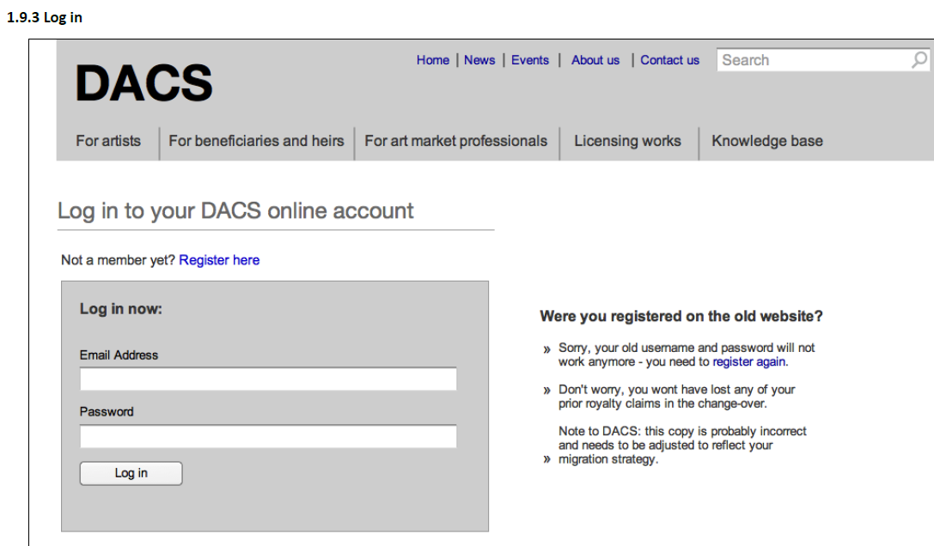

NB: this screen is prompting for an email address, login to the (payback) secure area requires a username (which is not an email address but a user selected name).

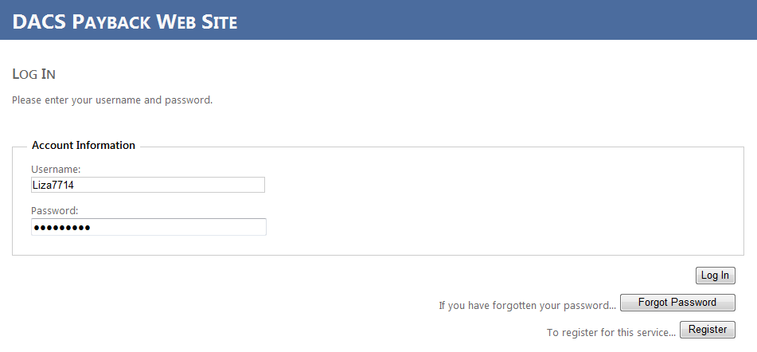

If the user is already an online member, they should just select the ‘Already a payback member’ and they will be taken to the same login screen where they will enter their user credentials of username and password.

Artists/beneficiaries/authorised representatives and sister societies that have submitted payback claims in the last three years, will have webuser records created for them and they will be sent their login details. Currently, in order to submit an online payback claim, a user must have a webuser login. Note – need to understand process for being sent user details.

NB: The username field is not an email address.

On successfully logging into the members area, the user will be presented with the DACS Members area where they can view/amend personal details, bank details and WHT. In addition they can also view/submit payback claims. This area could easily be extended to provide access to the other business stream services provided by DACS as and when they come online.

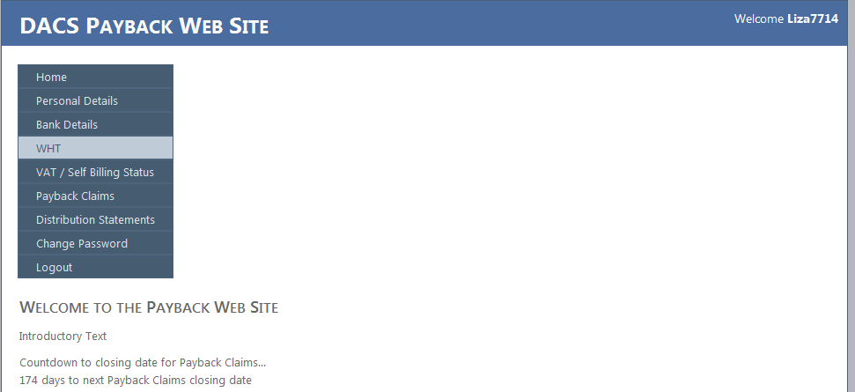

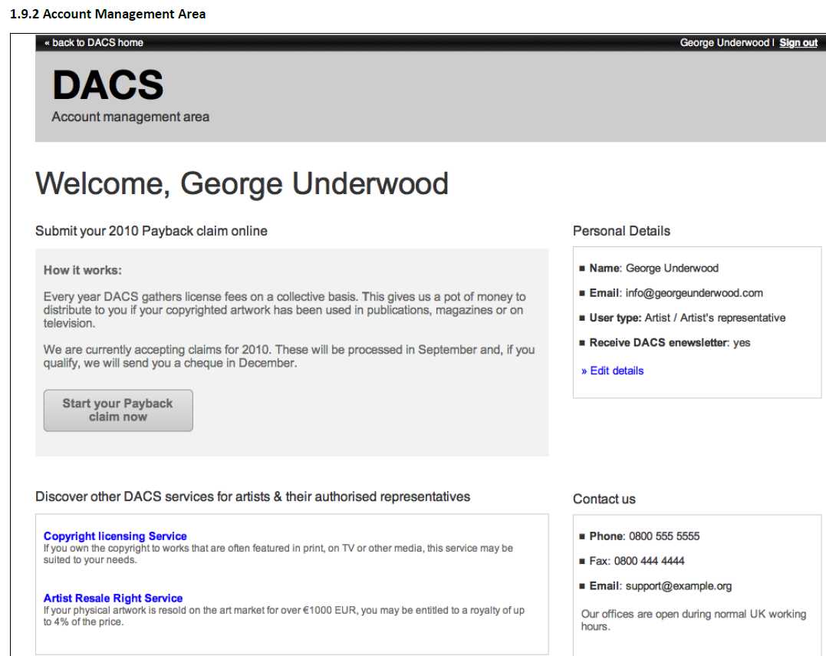

We need to ensure that the secure membership area wireframes are correct and match up with what has initially been developed for the payback area. Need to then apply the design skins to the payback functionality area.

Customisations: On line forms/Calculators etc...

Artists:

Register your interest for Copyright Licensing Service

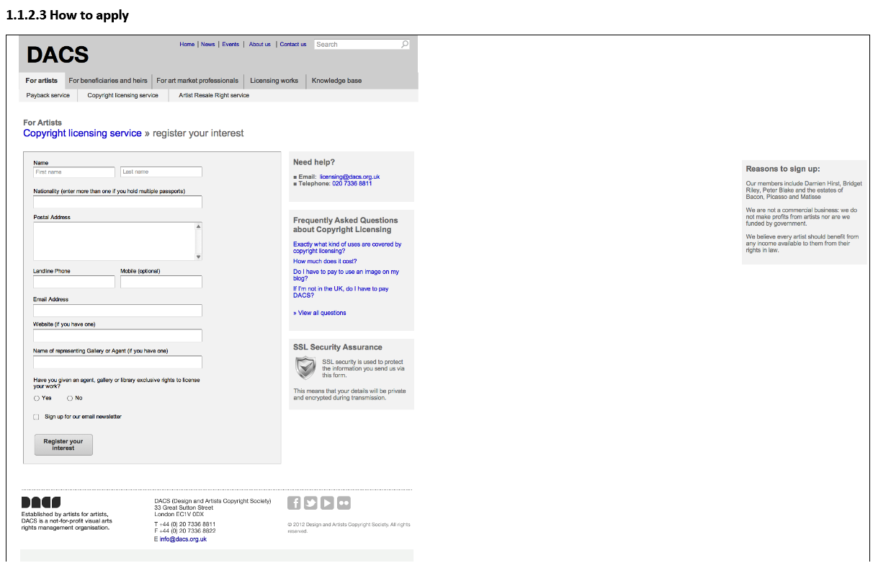

Artists submitting a ‘register your interest’ for CL are not a CL Member of DACS, however, they could be an ARR Member of DACS. This online form is simply allowing the Artist to instigate a manual process with DACS whereby they will then be assessed to see whether they meet DACS’s requirements for representation. DACS will manually process this form on receipt of it.

Volumes

30 =  new registrations per month for ARR membership

20 = general “membership” enquiries per month including CL

5 = CL packs requested and sent out per month

Unsure of CL \***customer**\* intereactions, can find out.

**Recommended Approach**

Submission of form adds the details as a record into a custom table in the CMS and workflow associated with table sends a notification email to DACS CL representative to manually progress the request. Link in the email will allow DACS to view the record in the custom table. In addition, a confirmation message is presented back to the submitter with a unique reference for the application, see below, as well as a confirmation email sent to include a copy of their application.

NOTE – ensure that email with copy of application doesn’t contain sensitive informaiton

**Alternative Approach**

Submission of form triggers an email to DACS CL Representative for manual progression. This is not very secure.

|  |  |  |
| --- | --- | --- |
| **Field Name** | **Validation** | **Notes** |
| Title | **Drop down list** | **Does not appear on this form but does appear on ARR request. Inconsistency?** |
| First Name | Free text field | Inconsistent labels across forms |
| Last Name | Free text field | Inconsistent labels across forms |
| Nationality | Multiple selection allowed |  |
| Postal Address | Large text box, scrollable | Inconsistent labels across forms |
| Landline Phone | Numbers only | Inconsistent labels across forms |
| Mobile (optional) | Numbers only? Or allowing + |  |
| Email Address | Validate for email format address, ie @ | Inconsistent labels across forms |
| Website Address (if you have one) | Validate for website address, ie http or www. |  |
| Name of representing Gallery or Agent (if you have one) | Free text field |  |
| Have you given an Agent/Gallery or library exclusive rights to license your work? | Radial buttons – Yes/No |  |
| Sign up for our email newsletter | Tick box |  |
| Register your Interest | Action Button |  |

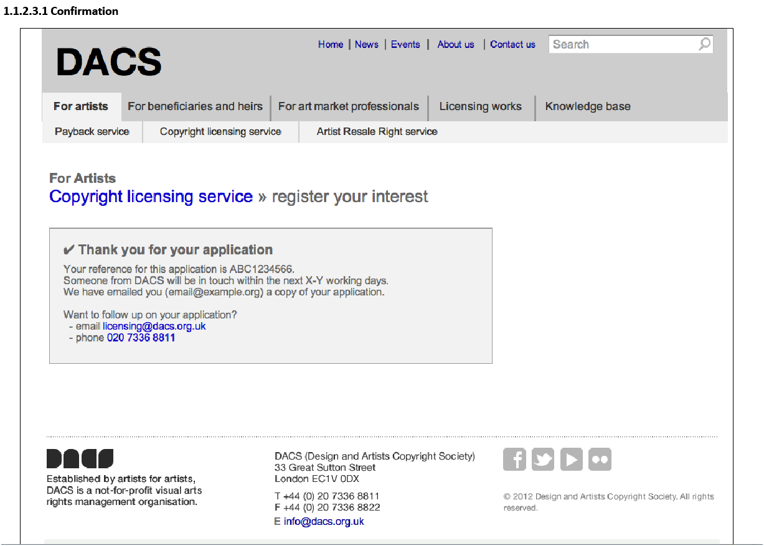

Confirmation message includes:

* Submission Reference – ABC1234566
* Indication of when contact will be made by DACS – days

ARR service Apply Online

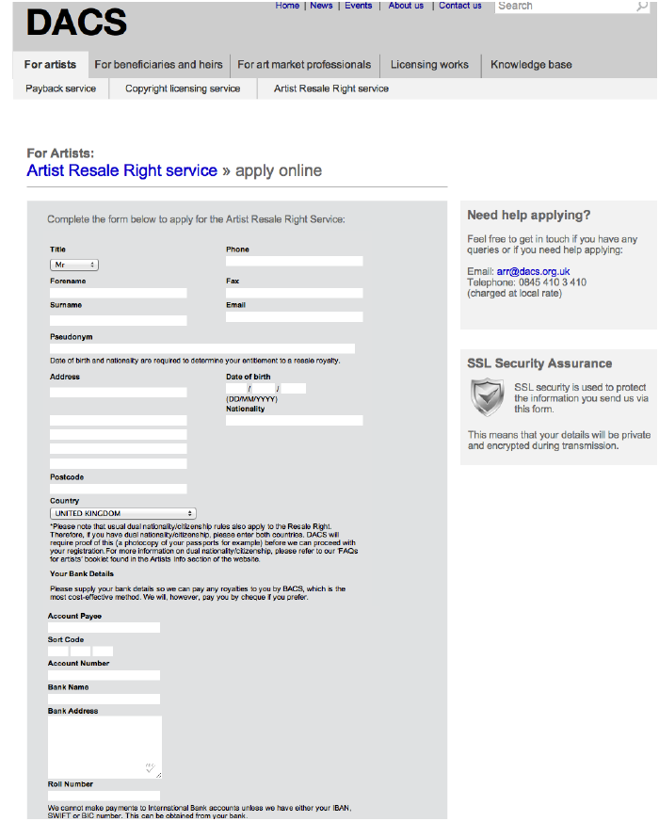

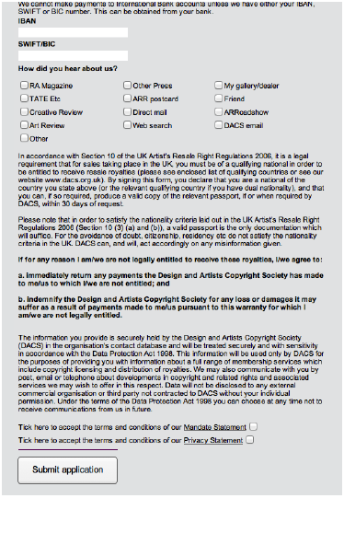

|  |  |  |
| --- | --- | --- |
| **Field Name** | **Validation** | **Notes** |
| Title | Drop down list | Inconsistent labels across forms |
| Forename |  | Inconsistent labels across forms |
| Surname |  | Inconsistent labels across forms |
| Pseudonym |  |  |
| Phone |  |  |
| Fax |  |  |
| Email |  |  |
| Nationality | Multiple selection allowed |  |
| Address | 5 separate lines | Inconsistent labels/fields across forms |
| Postcode | Separate line for postcode from address | Inconsistent labels/fields across forms |
| Country | Drop down list, separate line for country from address. Multiple selection allowed | Inconsistent labels/fields across forms |
| DOB | 3 separate fields DD/MM/YYYY |  |
| Nationality | Single line |  |
| Account Payee |  |  |
| Sort Code |  |  |
| Account Number |  |  |
| Bank Name |  |  |
| Bank Address | Large text box |  |
| Roll Number |  |  |
| IBAN |  |  |
| SWIFT/BIC |  |  |
| How did you hear about us | Set of tick boxes: 13 options |  |
| Mandate Statement | Tick Box |  |
| Privacy Statement | Tick box |  |
| Submit application | Action Button |  |
| Sign up for our email newsletter | Tick box | Not on this form, should it be? |
|  |  |  |

Artists applying on line for ARR are not an ARR Member of DACS, however, they could be an existing CL Member of DACS, or DACS could already be collecting ARR on behalf of the Artist even though they are not a member of ARR DACS. This online form is simply allowing the Artist to instigate a manual process with DACS, as long as they meet DACS’s requirements for ARR representation. DACS will manually process this form on receipt of it.

Volumes

30 =  new registrations per month for ARR membership

20 = general “membership” enquiries per month including CL

**Recommended Approach**

Submission of form adds the details as a record into a custom table in the CMS and workflow associated with table sends a notification email to DACS ARR representative to manually progress the request. Link in the email will allow DACS to view the record in the custom table. In addition, a confirmation message is presented back to the submitter with a unique reference for the application, see below, as well as a confirmation email sent to include a copy of their application.

**Alternative Approach**

1. Submission of form triggers an email to DACS ARR Representative for manual progression. This is not very secure, security becomes more important here as bank details are being requested on this form. AGREE – also need to check if we need to take bank details at this point.
2. NOTE – what happens if it’s an Auth Rep? Does this form support this?

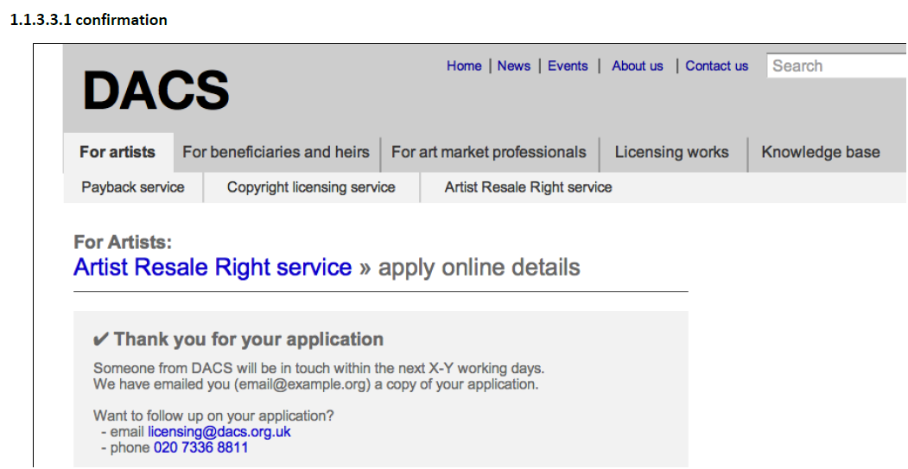

Confirmation message includes:

* Indication of when contact will be made by DACS – days
* Submission Reference – no reference included on this confirmation but there is one on the CL Confirmation ? Inconsistent.

**Require confirmation of time period for DACS to respond. Is this a set rule or hard text?**

Beneficiaries:

Register your interest for Copyright Licensing Service

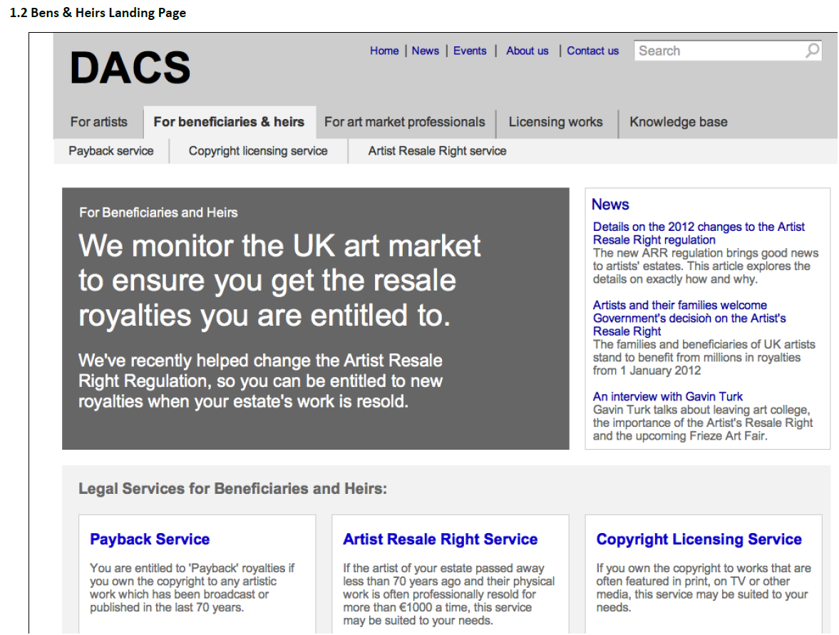

Also, doesn’t appear to be any other pages for Beneficiaries and Heirs for payback/CL and ARR service. Is this because they are exactly the same as the Artist pages (shouldn’t think so as the Beneficiary may have to put in additional information ie about themselves as well as the Artist they are the beneficiary of???? Check with KIM

YES – these are essentially the same pages and page tree structure just rewritten copy.

Page Title – Title Case (ie, first H1 in page)

Other titles, subtitles – Sentence Case.

Is the online form for B&H for CL request different? need the form example

Need to confirm whether this is an exact copy of the Artist CL request form or whether there are additional fields added for Beneficiary details. – confirmation required from DACS/Clearleft.

Beneficiaries and Heirs : ARR service

Is the online form for B&H for ARR request different? need the form example

Need to confirm whether this is an exact copy of the Artist ARR request form or whether there are additional fields added for Beneficiary details. – confirmation required from DACS/Clearleft.

Art Market Professionals

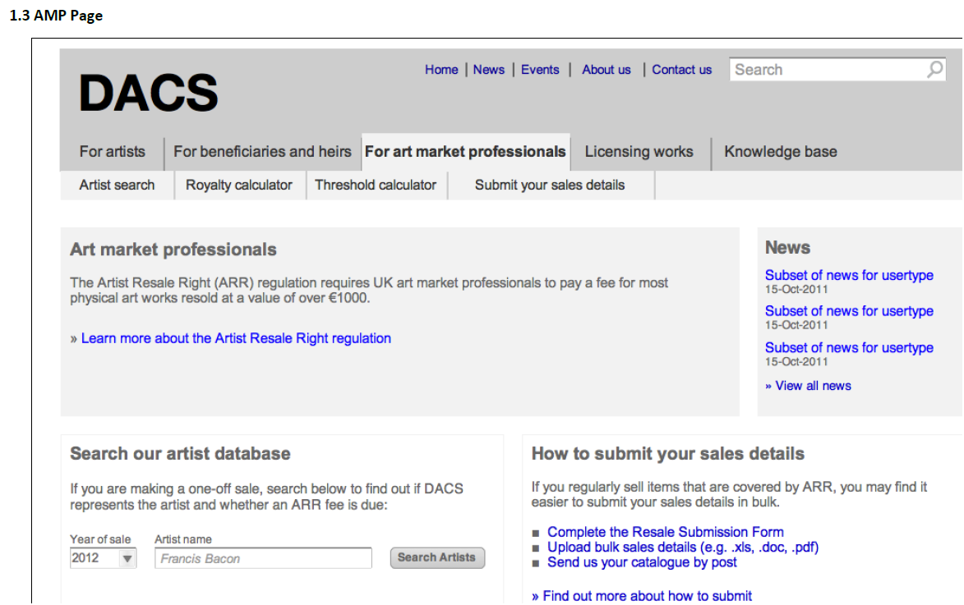

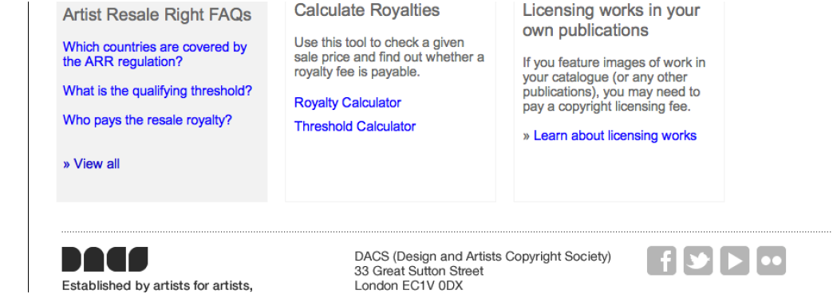

From the AMP landing page, users can search for an Artist by selecting the year of sale and entering the artist name into a free text field, then pressing Search Artists button. They could enter anything into the free text field.

|  |  |  |
| --- | --- | --- |
| **Field Name** | **Validation** | **Notes** |
| Year of Sale | Drop down selection of years YYYY |  |
| Artist Name | Single, free text field for entry of full artist name ie first and last name | Should it be a single field? Or two fields? |
| Search Artists | Action button | Leading capitals |

Before any results are returned from the search, a pop up is displayed asking for confirmation of T&Cs prior to the search completing. On confirmation, the search will complete.

**Need to confirm that this pop up is required in this format?**

Pre-search Interstitial

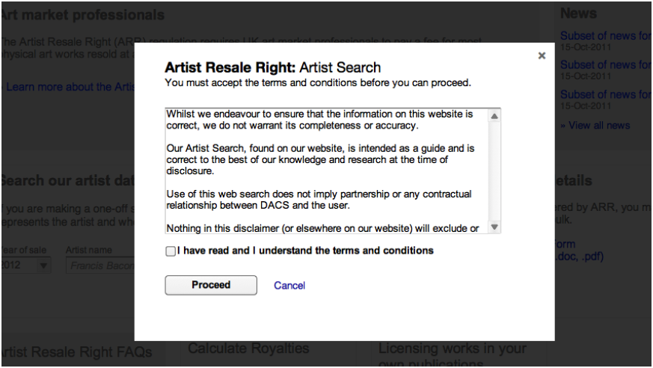

The results returned back will be in the same format as if you entered the search from the Artist Search page. Please see functional specification for Artist Search.

Royalty Calculator

There are two royalty calculators provided. One is standalone, ie no artist has been entered, and the other is from the Artist search page with a selected artist.

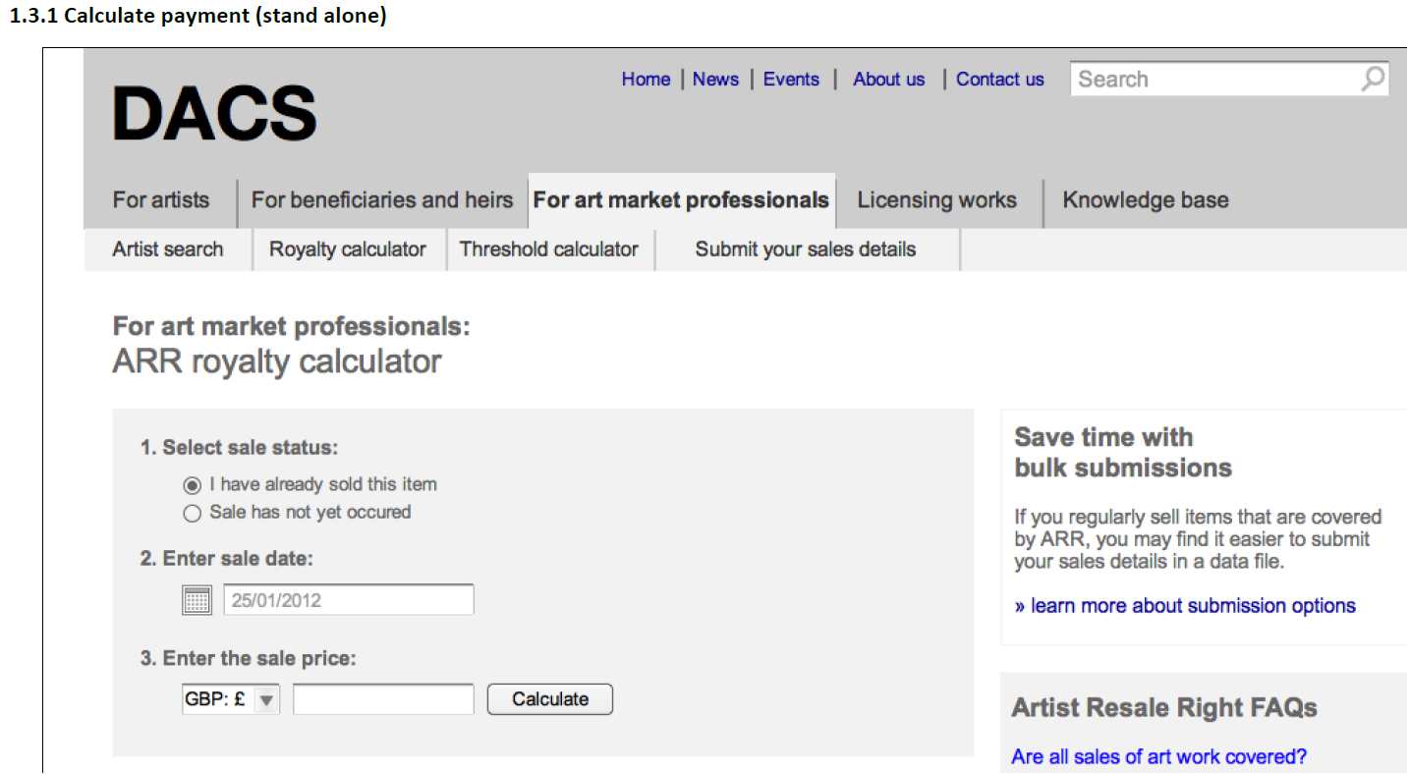

The royalty calculator allows AMPs to check what royalty fee, if any, is due for artworks sold above the euro threshold, currently set as 1000 euros.

|  |  |  |
| --- | --- | --- |
| **Field Name** | **Validation** | **Notes** |
| Select sale status: | Radial buttons, single selection  I have already sold this item/Sale has not yet occurred |  |
| Enter sale date: | Calendar widget, DD/MM/YYYY format single field |  |
| Enter the sale price: | Select currency eg GBP:£  Enter sale amount, numeric field |  |
| Calculate | Action Button |  |

The results of the calculation are then displayed indicating the ARR fee that would be due on this sale, if any. You are then also able to enter in the Artist name to search to see whether ARR is eligible and to whom the money should be paid.

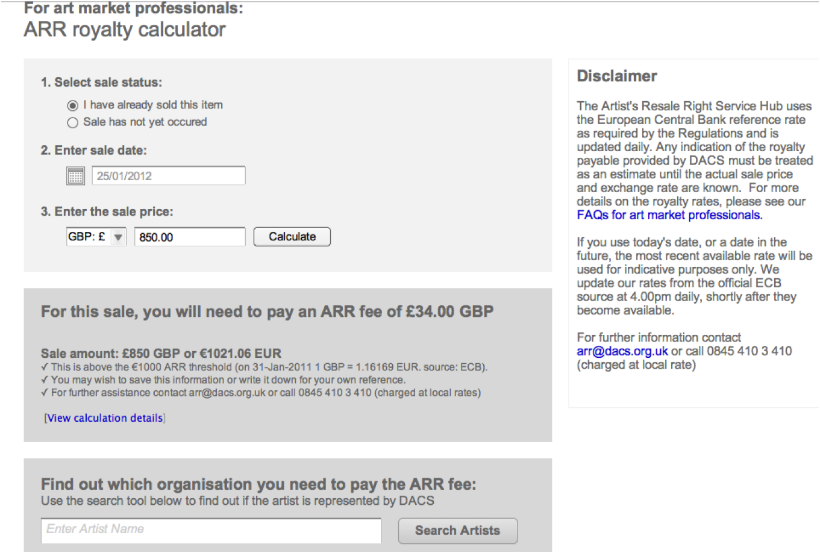

View calculation details – missing page – this link is now going to be removed.

Search Artists – find out which organisation you need to pay the ARR Fee:

Searches artists to see if artist is represented by DACS for ARR? Should be the same search and results as ARR search – see later section. NB: by Default DACS represents all artists for ARR unless otherwise specified, ie Sister Society or DACS mandated. – confirm this statement.

Threshold Calculator

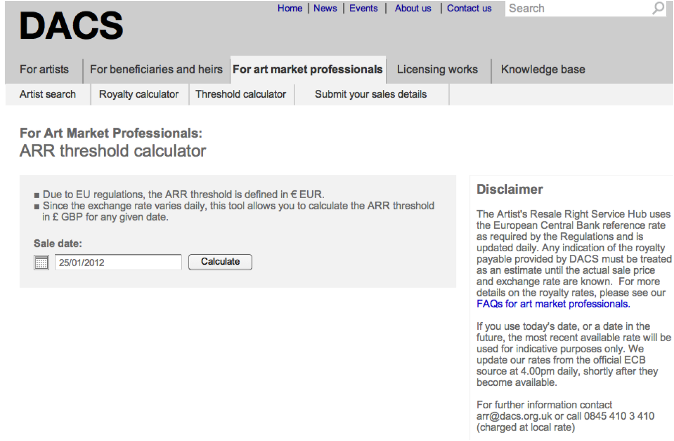

|  |  |  |
| --- | --- | --- |
| **Field Name** | **Validation** | **Notes** |
| Sale date: | Calendar widget, DD/MM/YYYY format single field |  |
| Calculate | Action button |  |

The ARR threshold where royalties are due is currently set at 1000 euros. This means that any sale of artwork, by an AMP, that exceeds 1000 euros will incur an ARR royalty fee, based on a set percentage. In order to check whether a GBP£ sale meets the threshold of 1000euros, the threshold calculator allows AMPs to identify what the equivalent GBP £ threshold is on a given date. Any sales made on that date that are over the equivalent GBP calculated threshold will then need to be submitted as ARR Sales. The exchange rate used is picked up from the ECB, updated at 4pm.

Threshold Results page – currently missing from wireframes

Presumably the same page with additional GBP currency field with equivalent value in pounds.

AMP: Submit your ARR online (low volumes)

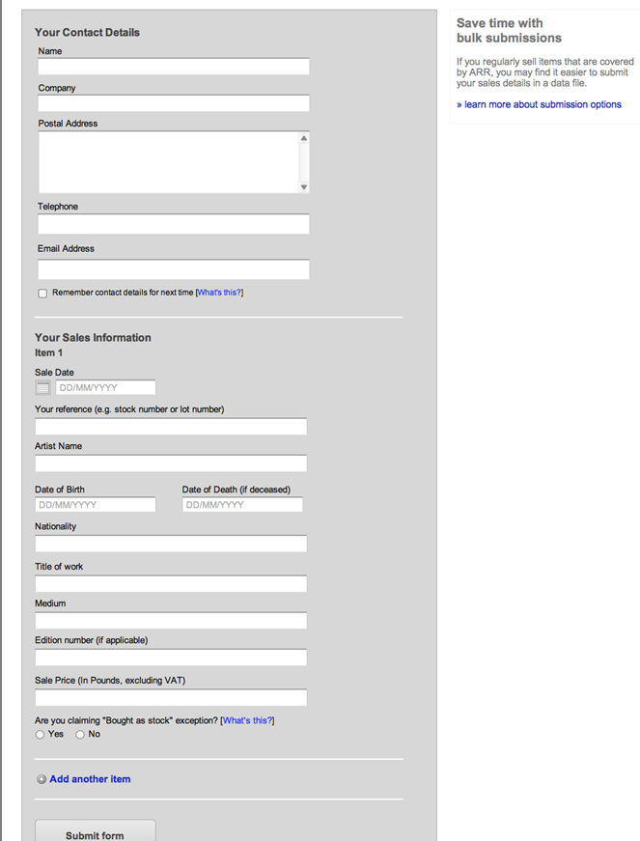

When an AMP submits ARR sales information online, they can submit via the online form if the volume of transactions is relatively low – their choice). We should add the option to sign up to emails/newsletters to the form like the CL request form.

|  |  |  |
| --- | --- | --- |
| **Field Name** | **Validation** | **Notes** |
| Name | Single field, maybe should be two fields, first name and surname, consistency! | Inconsistent labels across forms |
| Company |  |  |
| Postal Address | Large text box, scrollable | Inconsistent labels across forms |
| Telephone |  |  |
| Email Address |  | Inconsistent labels across forms |
|  |  |  |
| Remember contact details for next time? | Check box, cookie | Should this be on every form? |
| ***Sales Information*** | ***Repeatable set of fields on Add another item*** |  |
| Sale date | Calendar widget, DD/MM/YYYY |  |
| Your reference |  |  |
| Artist Name | Single field (should it be 2 fields? | Inconsistent labels/fields across forms |
| Date of Birth | Single field DD/MM/YYYY |  |
| Date of Death (if deceased) | Single field DD/MM/YYYY |  |
| Nationality | Single text field |  |
| Title of Work | Single text field |  |
| Medium | Single text field |  |
| Edition number(if applicable) | Single text field, any format? |  |
| Sale price (in pounds, excluding VAT) | Single text field, numeric? |  |
| Are you claiming ‘Bought as stock’ exception? | Radial buttons: Yes/No |  |
| Add another item | Link to repeat entry |  |
| Submit form | Action button |  |
| Sign up for our email newsletter | Tick box | Not on this form, should it be? |

The form, once submitted, goes where?

**Recommended Approach Phase 1**

CMS – Custom table created in CMS so each submission of this form creates a record in the table that then triggers an email notification to person responsible for progressing the request. Confirmation email to be sent to submitter with copy of information submitted included. NB: Any sensitive information should be excluded from the content of the email.

This would then entail manual copying of information into Triple R.

**Alternative Approaches**

Triple R – calls web service which receives form submission in XML format and then puts it into cases/queue or custom table in Triple R and sends notification for manual authorisation and workflow progression.– most secure option. Future development.

Email sent with details attached – this is least secure option.

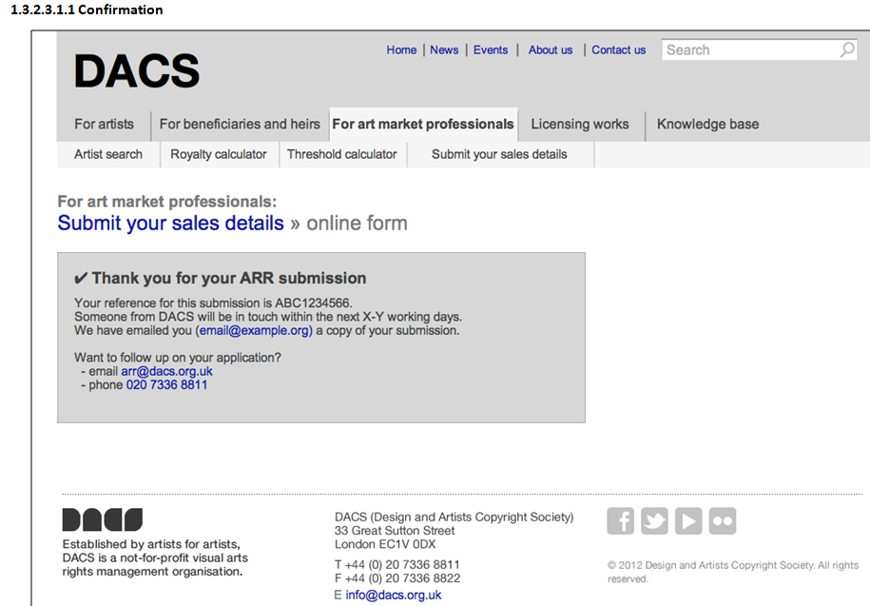

Confirmation message includes:

* Submission Reference – ABC1234566
* Indication of when contact will be made by DACS – days

Art Market Professionals Email Spreadsheet – Submit your ARR online (high volumes)

AMPs can email their data into DACS for manual upload into Triple R.

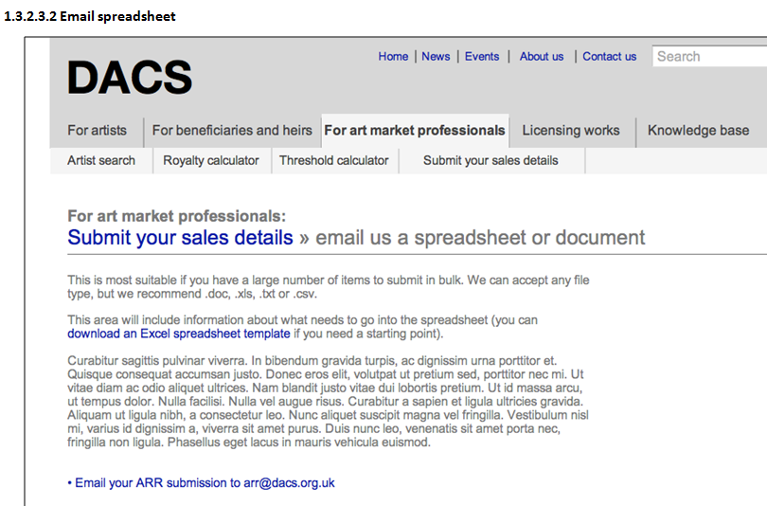

We will need to get hold of the template.

Customers

CL Apply Online - Licensing Copyrighted Works Online Submission

When a customer applies online to submit a copyright licensing request we could trigger a popup to ask whether they wish to sign up for email/newsletter notifications or not. These types of user do not require access to MyDACS as this is initially only targeting artists/ben/reps. However it could be extended to Customers of CL who could then view a history of submitted CL requests – future requirements?

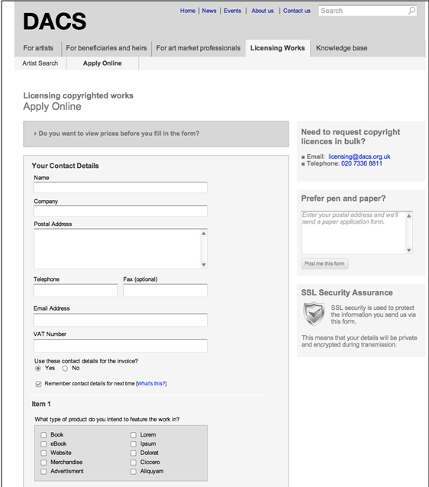

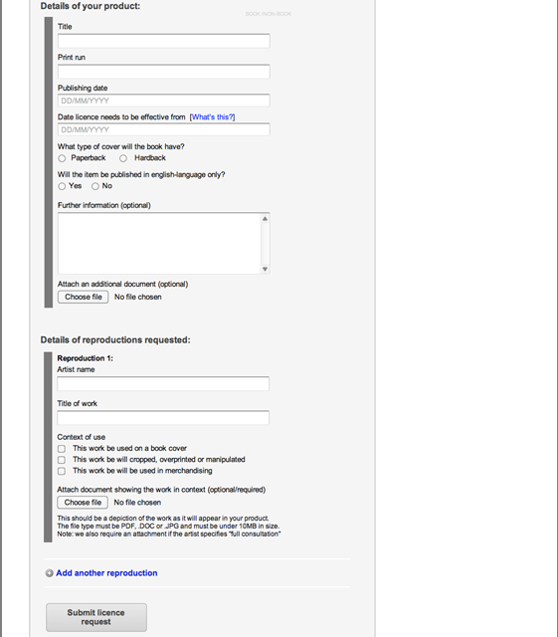

Volumes

Copyright Licensing customer enquiries, 200 forms received per month. Of these 100-150 become actual licenses (so – 50-75% conversion rate)

|  |  |  |
| --- | --- | --- |
| **Field Name** | **Validation** | **Notes** |
| Name | Single field, maybe should be two fields, first name and surname, consistency! | Consistent with ARR Sales submission, but not other forms |
| Company |  |  |
| Postal Address | Large text box, scrollable | Consistent with ARR Sales submission, but not other forms |
| Telephone |  |  |
| Fax |  | Inconsistent labels across forms |
| Email Address |  | Inconsistent labels across forms |
| VAT Number |  | Does not appear on any other form? |
| Use these contact details for the invoice? | Radial buttons: Yes/No |  |
| Remember contact details for next time? | Check box, cookie | Should this be on every form? |
| ***Sales Information*** | ***Repeatable set of fields on Add another item*** |  |
| Sale date | Calendar widget, DD/MM/YYYY |  |
| Your reference |  |  |
| Artist Name | Single field (should it be 2 fields? | Inconsistent labels/fields across forms |
| Date of Birth | Single field DD/MM/YYYY |  |
| Date of Death (if deceased) | Single field DD/MM/YYYY |  |
| Nationality | Single text field |  |
| Title of Work | Single text field |  |
| Medium | Single text field |  |
| Edition number(if applicable) | Single text field, any format? |  |
| Sale price (in pounds, excluding VAT) | Single text field, numeric? |  |
| Are you claiming ‘Bought as stock’ exception? | Radial buttons: Yes/No |  |
| Add another item | Link to repeat entry |  |
| Submit form | Action button |  |
| Sign up for our email newsletter | Tick box | Not on this form, should it be? |

The form, once submitted, goes where?

**Recommended Approach Phase 1**

CMS – Custom table created in CMS so each submission of this form creates a record in the table that then triggers an email notification to person responsible for progressing the request. This would then entail manual copying of information into Triple R.

**Alternative Approaches**

Triple R – calls web service which receives form submission in XML format and then puts it into cases/queue or custom table in Triple R and sends notification for manual authorisation and workflow progression.– most secure option. Results in CL order being created. Need to check that customer exists already in Triple R or create new customer before creating CL order.

Email sent with details attached – this is least secure option, but this may be what the plan is until ECR003 is complete.

ECR003 comes into play here – check with Chika what is happening at moment.

Job Application From?

Currently don’t have a wireframe page for this? To be confirmed by clearleft

Requirements for the form

* be able to post a page in CMS with information about job and how to apply
* this page to link to a zip file of documents for download
* need to monitor the number of downloads the pack gets (positive clicks – suggest using google analytics onclick events
* Ideally – Hannah would like it if you are FORCED to enter your email address before being able to download the pack, so she has a record of names.
* This would probably require a data protection statement / T&C statement next to it?
* The email address should be passed on to Hannah so if there’s a problem she can contact any applicants.

Do we have a screen shot of this page? I haven’t seen it in the wireframes document.

Interim Approach for Artist Search (CL, ARR and Artist A-Z)

Due to time constraints, and in an effort to ensure that we can meet the deadline for the website going live alongside the payback functionality, it is proposed that the Artist search area and associated data migration exercise be delivered as a second stage delivery after the go live date of 3rd July.

As a result of this, we will need an interim approach to support the artist search area. The interim approach will entail using the current artist search mechanisms ( as on the current website), with a move to the new artist search functionality at a later date. The interim approach will be outlined here and the final approach will be outlined in a separate functional requirements document part B.

FAQs

The FAQ section should be a simple Question and Answer linked to a category(this will be inherent depending on which page of FAQs they are set up on.. FAQ for each type of area, eg ARR, CL, Payback, will be setup on separate pages. There doesn’t appear to be any duplication of Q&As across areas

Potential categories could be

* Payback Service
* Copyright Licensing Service
* Artist Resale Rights service
* For Art Market Professionals
* Licensing Copyrighted Works (customers)
* Knowledge Base
  + (General Principles)
  + Copyright Infringement & Permitted Acts
  + Moral Rights
  + Licensing your Copyright
  + Copyright Advice Service
* For Artists
* For Beneficiaries and Heirs

Site Search & Results

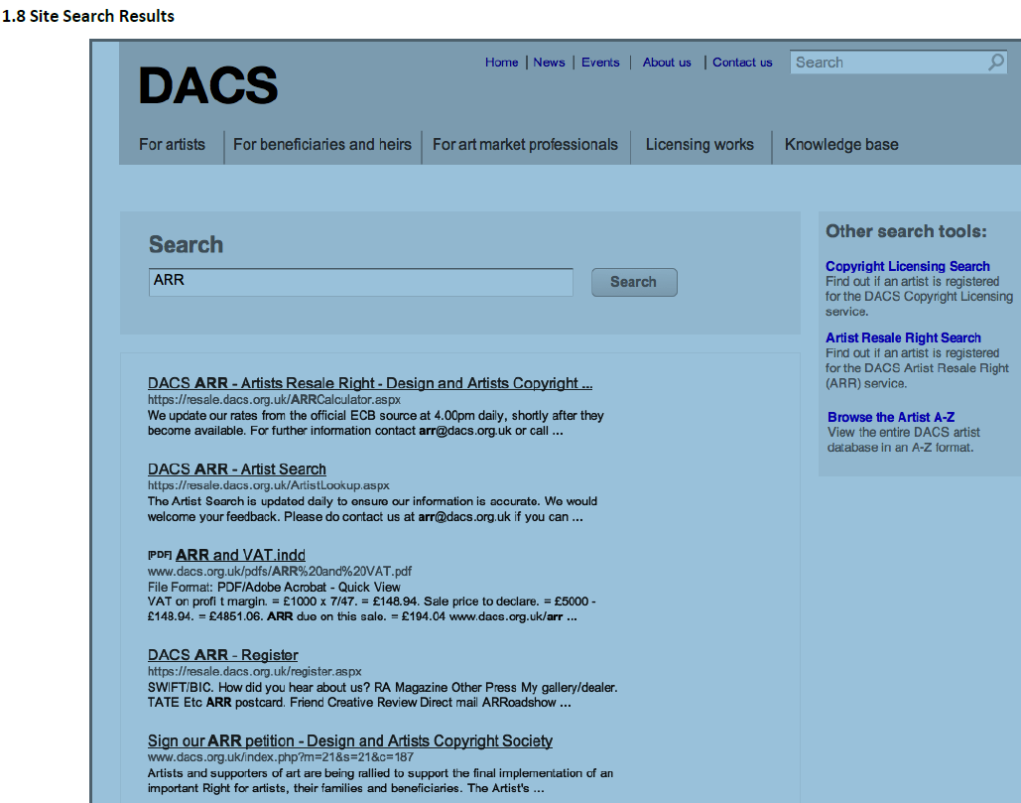

This is a standard content site search

Appendix A - Interfaces – as identified by Kim (07/03/12)

                Search - Site Content

                Search - Artists / ARR Results

                Search - Artists / CL Results

                Form - ARR register form

                Form - ARR Submit Sales Details Form

                Form - CL register form

                Form - CL Licensing Apply Online Form

                Form - Job Application?

                Form - newsletter signup

                Form - Registration, big 'ol payback form and signin area

                Form / Widget - Calculate ARR (including feed from ECB)

               Form / Widget - Calculate ARR Thresholds

                Internal Interface - update Artists Search data (TBD?)

                Internal Interface - CMS!

                System Interface - CMS / Artists Search Store

                System Interface - CMS / Payback Form / Triple R

                ? System Interface - CMS / MailChimp